CAMPING KAMNE

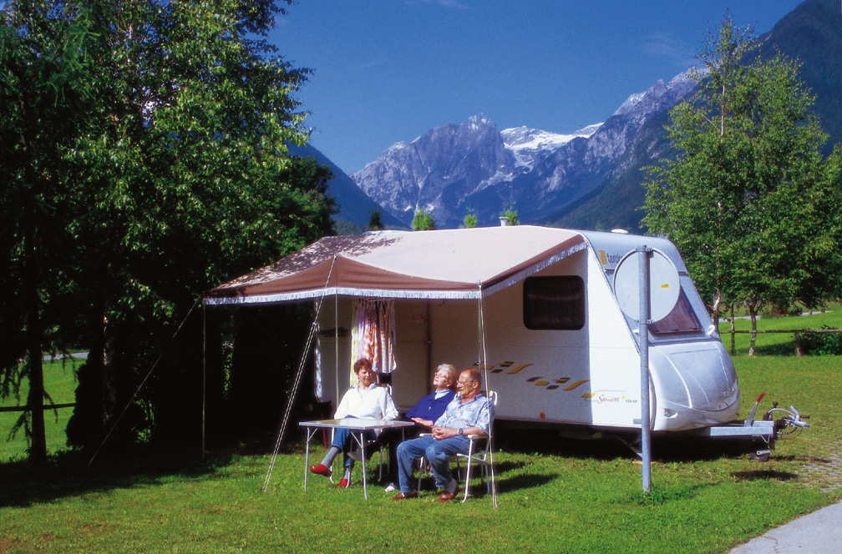

In an idyllic alpine resort Mojstrana, ''where mountains shake hands'', is situated the pleasant and peaceful Kamne campsite. You can stay in a tent, a caravan, a mobile home or hire a bungalow and admire a wonderful view on the highest peaks of Julian Alps.

Because the campsite lies in the immediate vicinity of Triglav National Park and its magnificent glacier valleys of Vrata, Kot and Krma, is the ideal starting point for numerous easy and more demanding outings into the Karavanke and Julian Alps and, most spectacularly, upon the slopes of Mount Triglav itself – the symbol of the Slovenian nation and State. All the necessary information about mountain tours and useful maps are available at the reception in the camp.

For those who find mountain climbing to difficult, there are a lot of possibilities for walking and sightseeing, such as waterfall Pericnik, Triglav's north wall, on the banks of river Sava and on the slopes of Karavanke. Rivers Sava and Bistrica are also appropriate for cayak or canu and for fishing. You can buy a fishing licence in the camp. There you can also rent a mountain-bike or they can get in touch for you with a mountain-guide. Recreation facilities include two tennis courts, table tennis, street ball and a small swimming pool. There is also a picnic place, where you can make your own barbeque.

Very interesting is also Dovje, the village with one thousand years of history, alpine architecture and still alive agrarian ''heart beat''. In the middle of the village is a specialised shop, where you can buy products from the farmers, who live near by. At the end of the village is St. Michael's church and its churchyard, where are buried many mountain climbers, who were unfortunately killed in this part of Julian Alps. Here is also buried Jakob Aljaz, the man who dedicated all his life to build mountain huts and mountain paths. His monument stands by the main road Jesenice – Kranjska Gora.

Welcome!

